PROGRAMMATIC THEORY OF CHANGE
Breaking the Cycle: CBT for Children in GBV-Affected Households
Programme design document — working draft for expert review
Prepared by Sungeun Kim

1. Programme Overview and Purpose
Breaking the Cycle is a structured cognitive behavioural therapy (CBT) programme for children living in households affected by gender-based violence (GBV). Its purpose is to interrupt the documented mechanism by which childhood exposure to family violence produces lasting psychological harm — and, if left unaddressed, transmits that harm into the next generation through cycles of victimisation and perpetration.
This document sets out the programme's Theory of Change: the causal logic connecting programme activities to immediate outputs, medium-term outcomes, and long-term impact. It does not prescribe final programme design, which will be determined through expert consultation and contextual analysis of the target population. Key design decisions — including session modality, frequency, group composition, and delivery setting — remain open and are flagged explicitly throughout.

2. Problem Statement
Children in GBV-affected households face a dual burden: the acute psychological harm of witnessing or experiencing violence, and the structural barriers that prevent them from accessing help. The evidence base establishes three interlocking dimensions of the problem:

- Direct trauma exposure. Psychological harm.
- Clinically elevated rates of PTSD, depression, anxiety, and externalising behaviour problems.
- Disruption to emotional regulation, self-concept, and the capacity to form safe relationships.
- Cycle risk. Intergenerational transmission.
- Approximately one-third of children exposed to family violence go on to become victims or perpetrators of GBV in adulthood (van Rosmalen-Nooijens et al., 2013).
- Continued contact with an abusive parent who denies or minimises the violence is a documented barrier to recovery — it prevents children from constructing a coherent trauma narrative, which is a prerequisite for therapeutic progress (Holt et al., 2025).
- Structural exclusion. Access barriers.
- Children frequently prioritise protecting their parents over seeking help. Traditional services often require parental consent or involve long waiting lists, both of which are structurally inaccessible in GBV contexts.
- Programme design must therefore actively lower the threshold for access rather than relying on self-referral.

3. Evidence Base
The programme's Theory of Change is grounded in a substantial body of peer-reviewed research, systematic reviews, and programme evaluations. The evidence supports five core claims.
First, the problem is clinically significant and well-documented. Children in GBV-affected households show consistently elevated rates of PTSD, depression, anxiety, and externalising behaviour problems. Approximately one-third go on to become victims or perpetrators of violence in adulthood, establishing a clear intergenerational transmission mechanism (van Rosmalen-Nooijens et al., 2013; Holt et al., 2008).
Second, direct child engagement is necessary. The IMPROVE systematic review (Howarth et al., 2016) finds that programmes delivered only to the non-offending parent — without a direct child component — do not produce significant improvements in child outcomes. Effective recovery requires therapeutic engagement with the child directly, or with the parent-child dyad.
Third, CBT is the most evidence-supported modality for this population. Trauma-Focused CBT produces significant reductions in PTSD, depression, and shame in children aged 7–14, with effects documented across multiple programme models including TF-CBT, Child-Parent Psychotherapy, and the Kids' Club (Vickerman & Margolin, 2007; Howarth et al., 2016; Graham-Bermann et al., 2007). Core components — trauma narratives, cognitive restructuring, emotion regulation, and safety planning — each carry independent empirical support.
Fourth, therapeutic gains are durable. A long-term mixed-methods evaluation found that most children retained their gains 4–5 years after TF-CBT completion, with the majority no longer meeting diagnostic criteria for PTSD (Onsjö et al., 2026). Evidence from the STYL programme in Liberia further demonstrates that CBT-driven reductions in violent behaviour can persist for at least ten years (Blattman et al., 2017).
Fifth, the approach is effective across contexts, including low-resource and GBV-specific settings. The Becoming a Man programme in Chicago reduced violent crime arrests by 20% and improved graduation rates by 9% among high-risk youth (Heller et al., 2017). Problem Management Plus, a brief psychotherapy model developed for low-resource settings, significantly reduced psychological distress among GBV survivors in Kenya (Bryant et al., 2017; Haushofer et al., 2023), confirming that structured psychotherapy can be adapted for real-world constraints without losing effectiveness.
The full evidence base, including detailed discussion of each study and a synthesis by programme modality and results level, is available in the accompanying literature review: Breaking the Cycle: Cognitive Behavioural Therapy for Children in GBV-Affected Households — Literature Review and Evidence Base.

4. Theory of Change
The programme's causal chain runs from therapeutic input through clinical outputs to outcomes, and ultimately to a impact: the interruption of the intergenerational cycle of GBV.
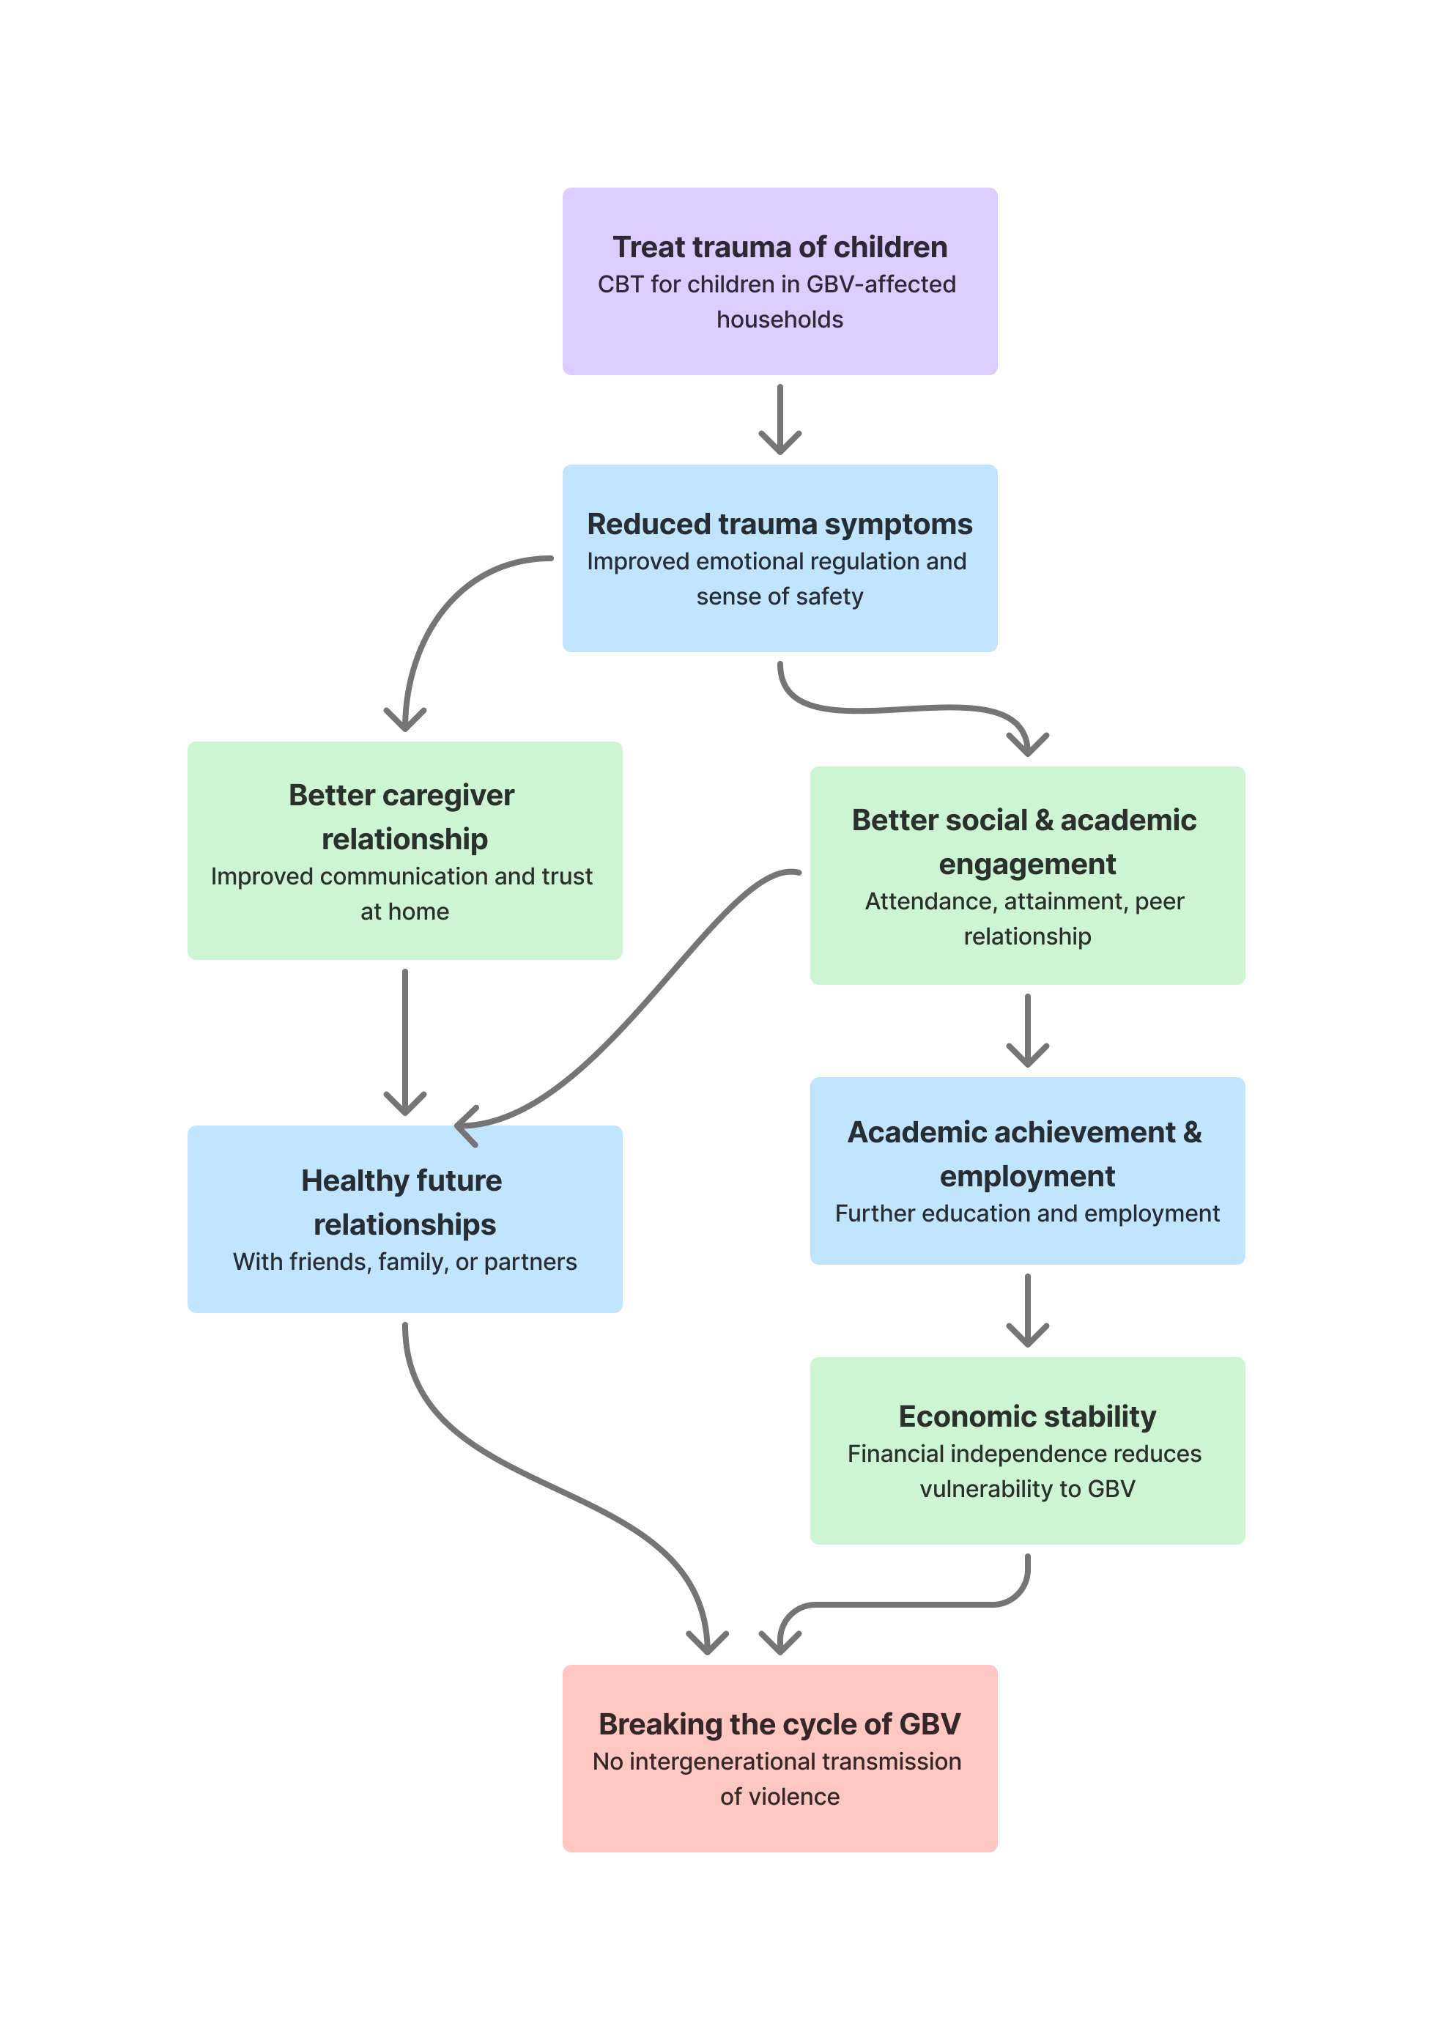
Figure 1 Theory of Change: Causal chain from therapeutic intervention to long-term impact

Table 1 Breaking the Cycle Programme Log Frame
Level | Objectives Hierarchy | Indicators | Sources of Verification | Assumptions
IMPACT | Break the intergenerational cycle of GBV  Long-term societal and individual freedom from cycles of violence | • Rates of violence perpetration or victimisation among programme graduates in adulthood (self-reported and administrative)  • Economic stability indicators: sustained employment, post-secondary enrolment, stable income at 5- and 10-year follow-up  • Rates of healthy, non-violent intimate and family relationships in adulthood | • Long-term follow-up surveys (5 and 10 years post-programme)  • Police and court records  • Self-reported data using validated instruments  • National / regional administrative data on employment and education | • Programme effects persist beyond the intervention period (supported by STYL 10-year evidence)  • Broader social, economic, and policy environment does not systematically undermine therapeutic gains  • Graduates maintain access to support structures in adulthood if needed
OUTCOME | Improved psychological wellbeing enabling sustained academic and social functioning  Stabilised wellbeing as the foundation for re-engagement in education and relationships | • Grade point average at 6 and 12 months post-programme  • School attendance rate  • Enrollment, grade progression, and graduation rates  • % of participants reporting positive peer relationships and reduced social withdrawal | • Annual follow-up surveys with participants and caregivers  • School records (attendance registers, report cards, enrolment data)  • Standardised assessment tools administered at 6 and 12 months | • School environments are safe and supportive of children’s return and continued attendance  • Improvements in psychological wellbeing translate into improved academic engagement (supported by BAM graduation-rate evidence)  • Families remain in sufficient stability to support school attendance
OUTPUT | Reduced trauma symptoms and strengthened emotional regulation  Measurable therapeutic change in children completing the programme | • % reduction in trauma symptom scores (UCLA PTSD Reaction Index or equivalent), pre/post  • % improvement in emotional regulation scores (pre/post)  • % of participants reporting an increased sense of personal safety | • Pre/post validated screening tools (UCLA PTSD-RI, SCARED, or equivalent)  • Facilitator observation logs and clinical supervision records  • Participant self-report surveys at completion and 6-month follow-up | • Participants attend a sufficient number of sessions to experience therapeutic benefit  • Children are not in continued contact with the abusive parent in a way that re-traumatises them during treatment  • Facilitators implement the CBT curriculum with fidelity
INPUT / ACTIVITIES | Delivery of structured CBT programme to children in GBV-affected households  Structured sessions by trained facilitators, with a parallel caregiver support strand | • Number of participants enrolled and retained  • Number of sessions completed per participant  • Number of trained and supervised facilitators deployed  • % of non-offending caregivers engaged in the parallel support strand | • Attendance registers and session completion logs  • Facilitator training records and clinical supervision logs  • Programme monitoring and management information system | • Facilitators are adequately trained and receive ongoing clinical supervision  • Participants have consistent access to safe, confidential programme spaces  • Non-offending caregivers are willing and able to support participation  • Adequate and sustained programme funding and management infrastructure is in place

4.1 Input: Structured CBT Delivery
What happens: Trained facilitators deliver a structured, evidence-based CBT programme to children in GBV-affected households. A parallel support strand engages the non-offending caregiver.

Programme design decision — modality (to be determined by experts)
The programme may be delivered as individual (1:1) sessions, group sessions, or a mixed model combining both. The appropriate modality will be determined following expert consultation and detailed analysis of the target population's characteristics, needs, and vulnerabilities.

Group delivery offers peer normalisation and cost efficiency. Individual delivery offers privacy and trauma-sensitive pacing. A mixed model may capture the benefits of both. No modality is prescribed at this stage.

Programme design decision — location and access (to be determined by experts)
Session locations will be selected based on proximity and practical accessibility for participating children. For group sessions, venues must be safe, confidential, and reachable without requiring children to disclose participation to the abusive parent.

Location siting decisions will be made in consultation with local partners, safeguarding leads, and the communities being served.

4.2 Output: Reduced Trauma Symptoms
What changes: Children completing the programme demonstrate measurable reductions in trauma symptom severity, improved emotional regulation, and a strengthened sense of personal safety.
The specific CBT components driving these changes — trauma narrative work, cognitive restructuring, emotion regulation skills, and safety planning — are each supported by the evidence base. The output is the proximate, clinically measurable result of the intervention.
Critical assumption: Children must be able to attend a sufficient number of sessions to reach the therapeutic dose. Where children remain in direct, unmitigated contact with an abusive parent who denies the violence, the programme's clinical team should assess whether continued participation is therapeutically indicated, and whether additional safeguarding measures are required.

4.3 Outcome: Improved Social and Academic Engagement
As trauma symptoms reduce and emotional regulation improves, children are better placed to engage with the social and educational environments around them. This includes school attendance, academic performance, and the quality of peer relationships. Evidence from the Becoming a Man (BAM) programme demonstrates a direct causal link between structured CBT and improved graduation rates — a pathway that operates through exactly this mechanism.
Academic and social re-engagement is also intrinsically protective: school provides structure, trusted adults, and peer connection — all of which buffer against the re-emergence of trauma symptoms after the programme ends.
This improved engagement then opens a forward-looking pathway. Children who re-engage with education are better positioned to pursue further academic achievement and, ultimately, secure stable employment. Economic stability — sustained income and financial independence — in turn reduces vulnerability to GBV in adulthood in two directions: it lowers the material conditions that increase exposure to victimisation, and it reduces the stressors associated with perpetration.
It should be noted that two additional outcomes — an improved relationship with the non-offending caregiver, and the capacity to form healthy, non-violent relationships with others in adulthood — are not captured in the log frame due to measurement complexity, but are expected to contribute independently to the programme's long-term impact. A child who develops a secure caregiver relationship during treatment is less likely to replicate violent relationship dynamics in adulthood; and a young adult who forms healthy intimate and family relationships is, by definition, not transmitting the cycle of GBV to the next generation. These outcomes operate alongside the economic pathway and reinforce the overall impact, even where they are not formally tracked.

4.4 Impact
Breaking the intergenerational cycle of GBV: programme graduates do not become victims or perpetrators of GBV in adulthood at significantly higher rates than the general population. The STYL programme in Liberia demonstrates that CBT-driven reductions in violent behaviour can persist for at least ten years — providing a strong evidential basis for this long-term impact claim.

5. Key Assumptions and Risk Considerations
The Theory of Change rests on several assumptions. Where these do not hold, the programme may require adaptation.

Assumption | Risk if assumption does not hold
Participants attend sufficient sessions to reach the therapeutic dose. | Insufficient dosage reduces clinical effect. Mitigated by accessible locations, flexible scheduling, and caregiver support.
Non-offending caregivers are willing and able to engage in the parallel support strand. | Without caregiver engagement, post-treatment communication reverts to pre-treatment patterns, reducing durability of gains.
School environments are safe and supportive of children's re-engagement. | Academic outcome pathway is weakened if school is itself a source of harm or exclusion.
Facilitators maintain programme fidelity with adequate clinical supervision. | Drift from the CBT curriculum reduces effectiveness. Mitigated by training standards and supervision protocols.
Official school data can be accessed under an appropriate data-sharing agreement. | Academic index reverts to standardised assessment tools. Continuity of measurement is maintained but comparability with administrative records is lost.
Programme effects persist after the intervention ends. | Supported by 10-year STYL evidence and 4–5 year TF-CBT follow-up data. Durability is reinforced by continued caregiver communication.

6. Next Steps for Programme Design
The following decisions require expert input and contextual analysis before programme implementation:
- Session modality (1:1, group, or mixed): analysis of target population size, trauma severity profiles, and resource constraints.
- Location and venue selection: mapping of participant residences, safe venue options, and transport or mobility barriers.
- Data-sharing agreements with school administrations: legal and institutional framework for academic data access.
- Intake assessment and safeguarding protocol: criteria for participation, abuser-contact assessment, and escalation procedures.
- Facilitator recruitment, training standards, and clinical supervision structure.
- Evaluation design: consideration of comparison group, outcome assessment independence, and follow-up timeline.

Reference

Blattman, C., Jamison, J., & Sheridan, M. (2017). Reducing crime and violence: Experimental evidence from cognitive behavioral therapy in Liberia. American Economic Review, 107(4), 1165–1206.

Bryant, R. A., et al. (2017). Effectiveness of a brief behavioural intervention on psychological distress among women with a history of gender-based violence in urban Kenya. PLoS Medicine, 14(8).

Cohen, J. A., Mannarino, A. P., & Deblinger, E. (2006). Treating trauma and traumatic grief in children and adolescents. Guilford Press.

Graham-Bermann, S. A., Lynch, S., Banyard, V., DeVoe, E. R., & Halabu, H. (2007). Community-based intervention for children exposed to intimate partner violence: An efficacy trial. Journal of Consulting and Clinical Psychology, 75(2), 199–209.

Haushofer, J., Mudida, R., & Shapiro, J. (2023). The comparative impact of cash transfers and a psychotherapy program on psychological and economic well-being [Working paper].

Heller, S. B., et al. (2017). Thinking, fast and slow? Some field experiments to reduce crime and dropout in Chicago. The Quarterly Journal of Economics, 132(1), 1–54.

Holt, S., Buckley, H., & Whelan, S. (2008). The impact of exposure to domestic violence on children and young people: A review of the literature. Child Abuse & Neglect, 32(8), 797–810.

Howarth, E., Moore, T. H. M., Welton, N. J., et al. (2016). IMPRoving outcomes for children exposed to domestic violence (IMPROVE): An evidence synthesis. NIHR Journals Library.

Onsjö, M., Axberg, U., Hultmann, O., & Strand, J. (2026). A mixed-methods evaluation of long-term outcomes after trauma-focused cognitive behavioural therapy for children subjected to family violence. Psychotherapy Research, 36(2), 324–338.

van Rosmalen-Nooijens, K. A. W. L., Prins, J. B., Vergeer, M., Wong, S. H., & Lagro-Janssen, A. L. (2013). "Young people, adult worries": RCT of an internet-based self-support method "Feel the ViBe" for children, adolescents and young adults exposed to family violence, a study protocol. BMC Public Health, 13, Article 226. https://doi.org/10.1186/1471-2458-13-226

Vickerman, K. A., & Margolin, G. (2007). Post-traumatic stress in children and adolescents exposed to family violence: II. Treatment. Professional Psychology: Research and Practice, 38(6), 620–628.

